6A^{th} Grade: Unit 13, Lesson 6

- Which scenario could be represented by the expression $15÷3$?
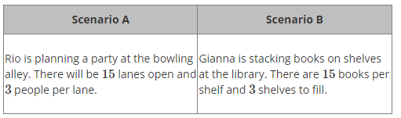

Neither Scenario

- What written phrase represents the expression 6y?

The product of 6 and y or 6 times y (or equivalent)

- Leyla and Mia were comparing the number of points they each scored over the course of the basketball season. Leyla scored 131 points, which was 92 points less than Mia. How many points did Mia score?

223

